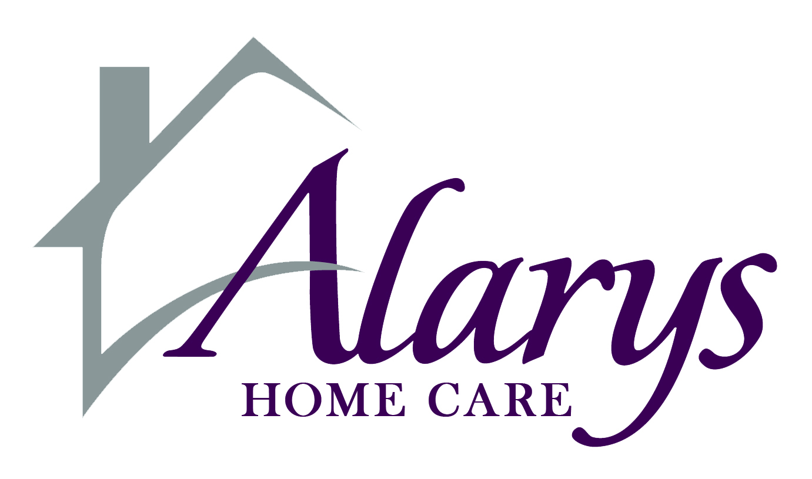
Please fax this form to (480) 445-9930 no later than Monday at 10:00am.

NOTE: Falsification of time sheets will result in termination. Print all information clearly – Illegible and incomplete information or late submission of time sheets WILL delay payment.

_______________________________________________

Provider Name (Last, First, MI)
Week of

________/_______/2016

through

_______/________/2016

__________________________________________________

Client Name (Last, First, MI)

DDD VISIT NOTE
 |  | SUN | MON |  | TUES |  | WED |  | THUR | FRI | SAT
 | Date:
 | Time in:
 | Time out:
 | Total Hours for
 | Habilitation:
 |  |  |  |  | Grand Total for HABILITATION Hours Worked:
 |  |  |  |  |  |  |  |  | (add up all HAB hours)
 |  | SUN | MON |  | TUES |  | WED |  | THUR | FRI | SAT
 | Date:
 | Time in:
 | Time out:
 | Total Respite
 | Hours:
 |  |  |  |  |  | Grand Total for RESPITE Hours Worked:
 |  |  |  |  |  |  |  |  | (add up all RESPITE hours)
 |  | SUN | MON |  | TUES |  | WED |  | THUR | FRI | SAT
 | Date:
 | Time in:
 | Time out:
 | Total Attendant
 | Hours:
 |  |  |  |  | Grand Total for ATTENDANT Hours Worked:
 |  |  |  |  |  |  |  |  | (add up all ATC hours)
 |  | Grand Total for HABILITATION, RESPITE AND ATTENDANT Hours Worked:
 |  |  |  |  |  |  |  |  | (add up all TOTAL hours)
 | Employee Signature/Title: |  |  |  |  |  |  |  |  | Date:
 | Responsible Party Signature*: |  |  |  |  |  |  |  |  | Date:
 | *Please do not sign until the end of the week and the DDD Visit Note is fully complete.
 |  |  |  | Questions? Call (480)444-7788

Alarys DDD Visit Note, Revised 12/2015

